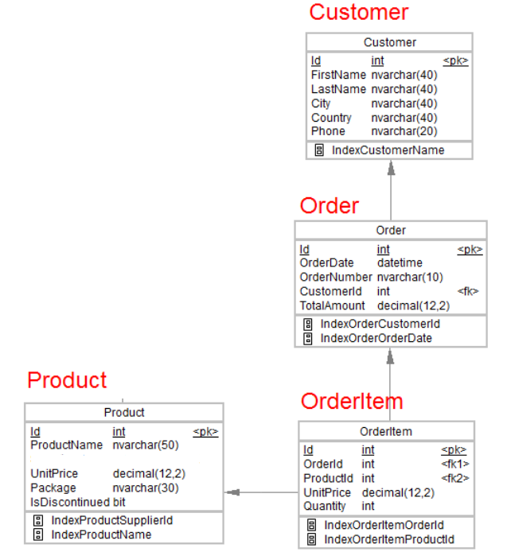

1. Design the above database with following table by applying Primary key and Foreign key
2. Insert Records in all tables
3. In Customer table FirstName Attribute should not accept null value
4. In Order table OrderDate should not accept null value
5. Display all customer details
6. write a query to display Country whose name starts with A or I
7. write a query to display whose name of customer whose third character is i
8. Display the details from Customer table who is from country Germany
9. Display the fullname of the employee
10. Display the customer details who has Fax number
11. display the customer details whoes name holds second letter as U
12. select order Details where unit price is greater than 10 and less than 20
13. Display order details which contains shipping date and arrange the order by date
14. Print the orders shipped by ship name 'La corne d'abondance' between 2 dates(Choose dates of your choice)
15. Print the products supplied by 'Exotic Liquids'
16. print the average quantity ordered for every product
17. Print all the Shipping company name and the ship names if they are operational
18. Print all Employees with Manager Name
19. Print the bill for a given order id .bill should contain Productname, Categoryname,price after discount
20. Print the Total price of orders which have the products supplied by 'Exotic Liquids' if the price is > 50 and also print it by Shipping company's Name